Meeting Summary
Date: Dec 06
Venue: BOCOM meeting room
Items
- Confirm contents and milestones for first phase cooperation
  - Contents: Technical Analysis driven trading assistant
    - Holding monitor
    - Pattern and indicator intelligent analysis
  - Milestones
    - Jan 30th UAT
    - Mar 15th Release
  - To-Do
- A-share market data(hugangtong) - FDTAI
- Pattern-analysis(APIs) - FDTAI
- Readable report(Gateway) - FDTAI
- Transaction data(Gateway) - BOCOM
- Deliver page(H5) – FDTAI
  - For each holding stock
    - Call PA(API)
    - Display stock PA in past 60 days
    - Sort by [importance / predicted volatility etc]
  - Display as H5 into Front-end
- Regular meeting
  - Bi-weekly, on-site or video
- Person
  - BOCOM
    - Project Contact Person: Yumin
    - Product Manager: Yan
    - Tech Manager: Peter, John Cheng
  - FDT-AI:
    - Project Contact Person: Caleb
    - Product Manager: Wen(absent from this meeting)
    - Tech Manager: Jack
- Data Spec: see email archive
- Primitive UI

- Separate Pages
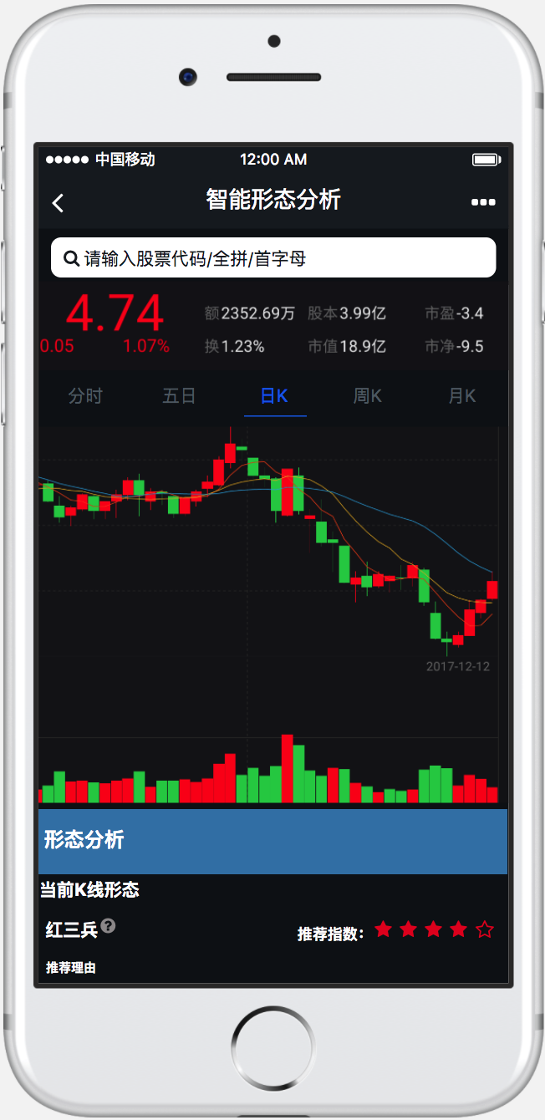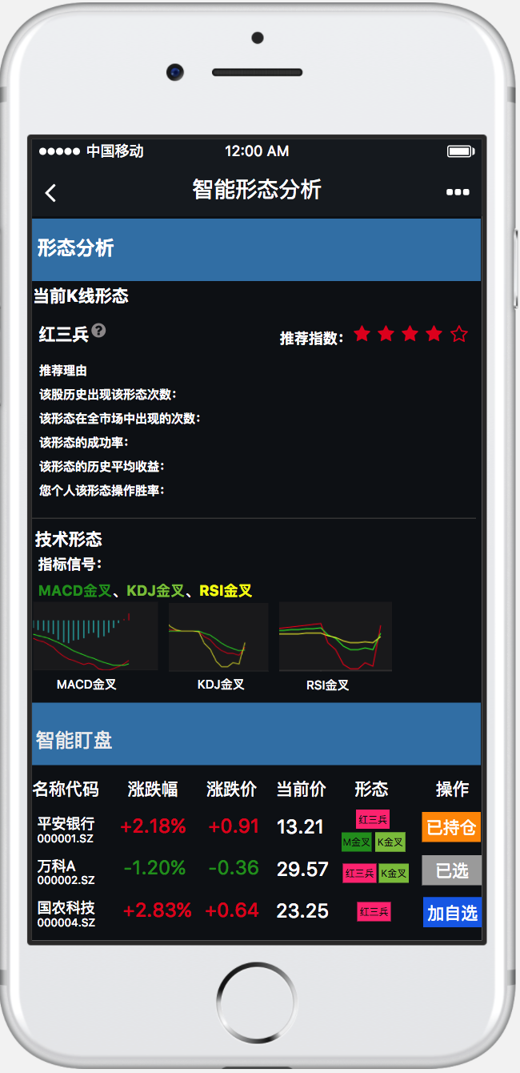

- Full Design
